

**“AZƏRBAYCAN HAVA YOLLARI” CJSC NATIONAL AVIATION ACADEMY**

**Individual Work № : 2**

**Topic:** **Processor manufacturers and brands.**

**Subject: OS2**

**Teacher: Mamed Shahmaliyev**

**Group: 1459i Student: Mehrali Babayev**

**Date: Signature: _____________**

**­ Baku 2022**

A Guide to the Different Types of Computer Processors

A computer's central processing unit, or CPU, controls the action and data flow in the computer. There are two major manufacturers of computer processors, Intel® and AMD®. For both manufacturers, there are three general lines of processors.

In all cases, a computer's CPU must be compatible with the motherboard, memory, power supply, and any graphics cards. [**Find out more about building a PC with our guide.**](https://www.crucial.com/articles/pc-builders/how-to-build-a-computer)

**Three levels of performance**

Both manufacturers of CPUs have three lines of processors based on performance, and of course, cost. These lines change names as the companies re-tool their products.

Budget processors are designed to run basic computer tasks efficiently and cost-effectively. These CPUs will easily handle most office programs, web browsing, photo editing, and other general tasks.

Budget processors have about 85% of the performance of a mainstream model. If you are upgrading your computer, a budget processor is more likely to be compatible with an older motherboard and slower memory.

Mainstream, or mid-range, processors can be physically larger and can handle higher-performance tasks such as 3D gaming, video editing, and other multimedia-intense applications.

Mainstream CPUs use more power and could have cores and caches that are not compatible with older motherboards and memory. If you upgrade your entire system, however, you will see a performance boost.

The fastest processors, known as extreme or high-end, are used for gaming, intensive graphics, creating and editing professional videos, and statistical analysis. If you are upgrading an existing computer, pay special attention to the specifications for compatible components. High-end CPUs use more power and require more memory. [**Read here for more information on gaming specifications.**](https://www.crucial.com/articles/for-gamers/the-best-specs-for-a-gaming-pc)

**Technology**

As all computer technology develops, cutting edge technology is introduced on the highest-end parts, then moves downward. This holds true for processors, as well. The current trend is to introduce more and more cores on each CPU. This causes a performance increase in multitasking environments, for example applications that use threading, such as a web browser. This increase in cores will trickle down to the mid-range and budget processors.

Another technology break-through is integrated memory controllers, which increase system performance by reducing memory latency. Integrated memory controllers are usually compatible with only some types of RAM, however.

The processor you select will depend on your budget and the other components of your system. Be sure to carefully check the compatibility of the CPU with all the other components of your system.

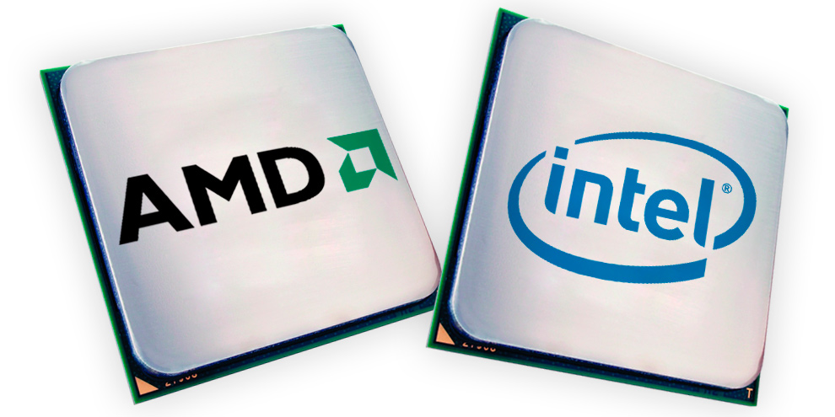

A small chip ‘processor’ has a huge role in electronic devices and computers. It receives input and provides the appropriate output.  With its dynamic innovation, Processors has been improvising in improving speed and boast great power. Modern processors can handle trillions of calculations per second. With new computing power processors are yet to see its best potential in coming time ‘Processors’ will be the real score card for processor manufacturers. Below Are Enlisted Top 10 Processors Manufacturers;

**4D Systems**

4D Systems is a popular name among [top 10](https://www.bisinfotech.com/top-10-digital-signal-processors-controllers-manufacturers/) Processors Manufacturers.  Its processors have the biggest popularity in all over the industry.  4D Systems’ has an extensive range of embedded displays fostering oLED and LCD technology. 4D Systems also delivers expertise in graphics processors.

Amulet Technologies has wide range of processors and just because of this reason it has achieved its name in top 10 processors [manufacturers](https://www.bisinfotech.com/top-10-system-on-chip-soc-manufacturers-of-2020/). As experts in the embedded industry, it makes the perfect HMI solution from concept to completion.

Broadcom Inc. is a global technology leader that designs, develops and supplies a broad range of processors. Broadcom is a known and well-versed company manufacturing communication network processors and embedded processors for consumer multimedia applications. Broadcom’s category-leading product portfolio serves critical markets.

**MaxLinear**

MaxLinear is the name which comes first when we talk about [processor](https://www.bisinfotech.com/top-10-digital-signal-processors-controllers-manufacturers/). It is a famous name in processor’s manufacturers. MaxLinear delivers high-performance broadband and networking semiconductors based on its highly integrated radio frequency analog technology, high-performance optical networking technology and its pioneering MoCA and Direct Broadcast Satellite ODU single-wire technology.

**Microchip**

Microchip Technology Incorporated is a leading provider of processor. Not only wide range of processor, it also has easy-to-use development tools and comprehensive product portfolio which enables customers to create optimal designs helping future-ready processors. Microchip processors cater to new computational powers and have been leading the market for years.

**NXP Semiconductors**

NXP Semiconductor’s processors are known as the world leader in secure connectivity solutions for embedded applications, NXP is driving innovation in the automotive, industrial & IoT, mobile and communication infrastructure markets.

**ON Semiconductor**

ON Semiconductor is a leading player in the processor market. One semiconductor processors makes a major market traction in the market. ON Semiconductor supplies image co-processors for use with advanced CMOS image sensors. ON semiconductor processors help engineers solve their unique design challenges various applications.

**Renesas Electronics**

Renesas Electronics provides a comprehensive lineup of processors. Renesas Powerful processors built around an Arm CPU. Renesas Electronics processors are used in various applications today and has been innovating in this space. Renesas provides comprehensive solutions for a broad range of automotive, industrial, infrastructure, and IoT applications that help shape a limitless future.

**ROHM Semiconductor**

Japanese based, ROHM Semiconductor is one of the processor manufacturer which has the biggest name in the industry. The company began manufacturing semiconductors. ICs and discrete semiconductors now account for about 80% of Rohm’s revenue.

**Texas Instruments**

Texas Instruments processors are widely-used in today’s applications. From Automotive processors to Digital Signal Processors, TI has been empowering excellence and innovation in this space. TI’s Sitara embedded processors and industrial processors offer optimized solutions that go beyond the core.